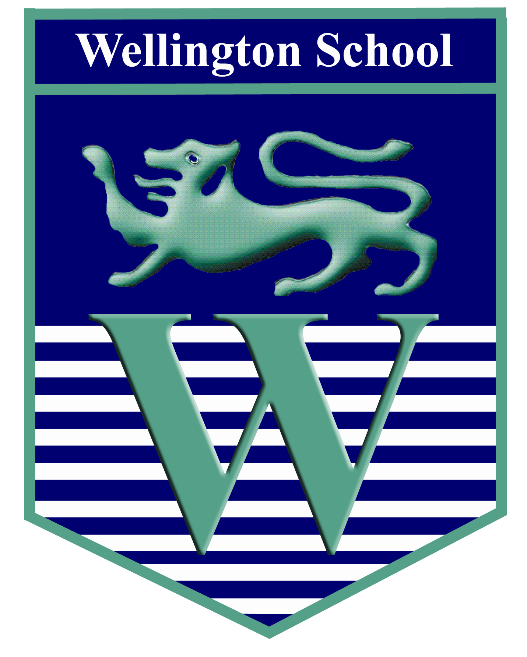

School Council
Thursday 1st December
Minutes

Meeting commenced: 3.10pm
Present: Mr Holt, Mrs Cook, Mrs Copeland
38 students attended the meeting.
Year 7 – 7
Year 8 – 8
Year 9 – 9
Year 10 – 9
Year 11 – 5

- Anti-bullying Ambassadors
Mrs Cook came to the meeting and addressed School Council members. She spoke to students about her work with Wellington’s Anti-Bullying Ambassadors and shared the view that everyone in the Wellington community wants it to be an even kinder and more welcoming place than it is already.

Not all students were aware of who the ABAs are and one of the reasons for Mrs Cook’s visit was to change that and raise the profile of the work which the team do around school. Students were made aware that they carry the Wellington Anti-Bullying policy around with them in their planner and Mrs Cook asked students to look at it and decide if it needed updating.

A questionnaire was distributed to all SC reps who will complete it during tutor period by asking the views of their tutor group. The questionnaires should be returned to Mrs Cook in room 56 by Wednesday 7th December. The following day (Thursday 8th), the results will be discussed by the ABAs and Mrs Cook extended an invitation to SC members to join them if the wished.

Anyone interested in attending should go to room 56, Thursday lunchtime

- Sponsored Walk 2017
The shortlist of 5 charities was presented to everyone present by members of the Executive Committee. To make the delivery of presentations as fair as possible, students could only refer to one slide and could only talk for one minute. The charities were as follows:

Kidscan – a children’s cancer charity presented by Hannah Gibson, Alex Chappell and Anna Casey

Rays of Sunshine – a charity which grants the wishes of seriously ill children, presented by Joseph Lee and Yasmin Lee
Rainbow Trust – a charity which provides help and support for the families of sick children, presented by Aaron Mellish

Alzheimer’s Society - presented by Ella Percy and Sarah Carter who described the work done for people with this disease

Once Upon A Smile – a local charity who provide services for people who are recently bereaved, presented by Amy Loftus

Everyone agreed that the choice was incredibly difficult as all causes are worth the valuable support of the school.
A secret ballot was held – democracy in action – and the ballot box whisked away for safekeeping by Mrs Copeland. We still have a little fund-raising to do for this year’s charity (Teenage Cancer Trust) and so results will be counted and shared immediately after the Christmas break when we launch next year’s charity effort.

- Learning Resource Centre – a chance to share your ideas
Following the retirement of Mrs Ware, Mrs Gilbert has taken charge of the LRC and has hit the ground running. Year 11 Librarian Tom Winwood-Rooney spoke to the SC about some ideas to improve the LRC for students and distributed a questionnaire which was completed by gathered students. These will be collated by the LRC staff and shared with students as soon as possible.

Several students took the opportunity to stand up and speak about their own ideas:
Hamish Gonzalez-Sweeney (Y9) suggested earlier opening hours. Ella Percy (Y9) and other librarians stated that they would be happy to open and run the LRC on a rota earlier than it currently opens. Amy Loftus (Y11) said that a warm drinks machine would be most welcome!

- Chocolate raffle
Due to the length of the first 3 items, discussion around individual and class reports, as well as feedback from the Trafford Youth Cabinet will be covered at the next meeting.

The return of the chocolate raffle saw 7 lucky members disappear into the evening clutching a well-earned reward.

Next full School Council meeting: Tuesday 31st January 2017

Meeting closed at 4.10pm

